ENEL 387

Functional Specifications

Variable Speed Drive

Brant Geddes

200350415

Table of Contents

1. System Information 1

1.1 Description 1

1.2 Diagram 1

1.3 Physical Layout 2

1.4 Applications 2

1.5 Electrical Ratings 3

2. Operation 4

2.1 Start Up 4

2.2 Normal Operation 4

2.3 Faults 5

3. Components 6

# 1. System Information

## 1.1 Description

The Variable Speed Drive (VSD) allows the user to control the average voltage delivered to a load using a microprocessor to control the firing angle of a TRIAC. Applications for the VSD include variable heat delivery from a heating element, light dimming applications, and variable DC motor speed control. The VSD operates at 120VAC with a maximum current rating of 15A and is connected using a typical 5-15R male corded end to the supply and a 5-15R female end to supply power to the load. The microprocessor system is easily scaled to higher voltage or current applications by replacing the power electronics section with another appropriately rated device. The device also includes a test point to inspect the resulting waveform and the instrumentation necessary to display load parameters such as voltage and current. All connections between the microprocessor and the power electronics are isolated magnetically through the use of a PT or CT or optically through the use of an opto-isolator. All high voltage equipment is contained in an appropriate box and wired according to CSA standards.

## 1.2 Diagram

The basic system components are shown below. The system contains two major sections, the microprocessor section and the power electronics section. The user interface is included in the microprocessor section.

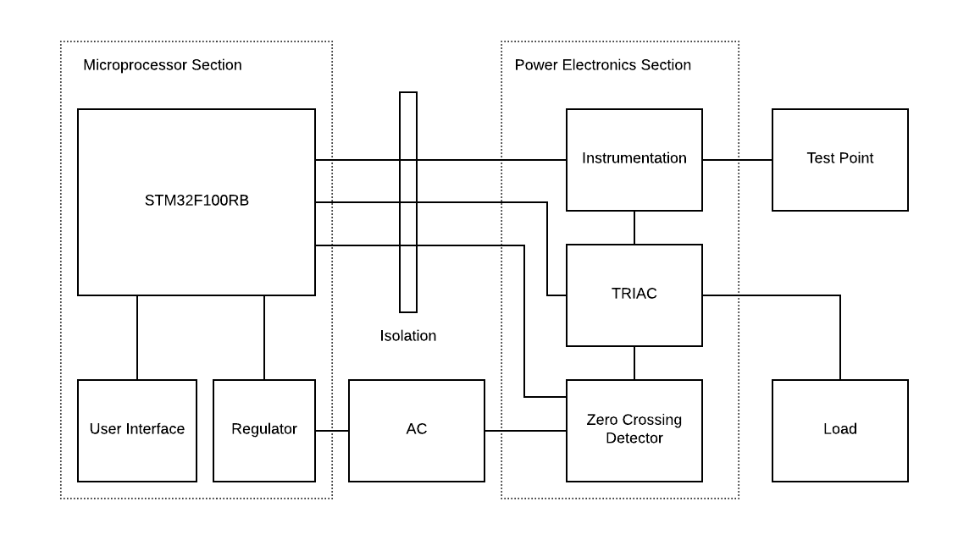

Figure 1 - Block Diagram of VSD

## 1.3 Physical Layout

The VSD contains two major sections, the Microprocessor section and the Power Electronics section. The microprocessor section contains the STM32F100RB microprocessor, the low voltage power supply, and the user interface. The user interface gives the user access to indicator LED’s, pushbuttons, a setpoint dial, and a 16x2 LCD screen:

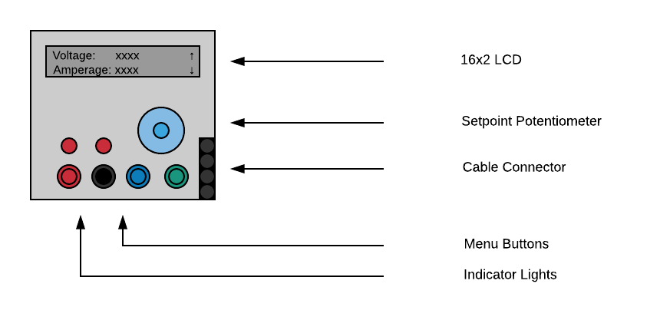

Figure 2 - User Interface Layout

The Power Electronics section contains the zero-crossing detector circuit, the TRIAC firing circuit, and the instrumentation and test circuit. The Power Electronics section is housed in a CSA approved box rated for 120V. In addition to the Power Electronics circuitry the box also contains an appropriate means of controlling over-current and the receptacles needed to connect the VSD to the load. Communication between the two sections is accomplished using a ribbon cable with appropriate isolation between high-voltage and low-voltage.

## 1.4 Applications

The major applications of the VSD include variable heating, light dimming, and variable DC speed control. By controlling the average voltage dropped across a heating element, the power dissipated by that element is also reduced. This can be used to reduce the heat output of a typical resistive heating element and provide an alternative to an ON-OFF thermostat control. Similarly, the light produced by a standard incandescent bulb is proportional to the power dissipated by the bulb. By changing the power at the bulb, the light that the bulb outputs is also changed. Finally, the speed of a DC motor is proportional to the voltage across the armature of the motor. By placing an appropriate bridge rectifier circuit at the output of the VSD the DC voltage delivered to the motor can be controlled, which in turn controls the speed of the motor.

## 1.5 Electrical Ratings

Operating Ratings:

|  |  |  |  |  |  |
| --- | --- | --- | --- | --- | --- |
| Rating | | Min | Typ | Max | Notes |
| Supply Voltage | VAC | 100 | 120 | 130 | -Appropriate 15A branch circuit |
| Amperage | A |  | 0 - 12 | 15 | -Continuous Draw |
| Test Output | VAC | 8.33 | 10.0 | 10.8 | -10VA Max loading |

# 2. Operation

## 2.1 Start Up

The VSD enters a start-up sequence when first powered up by connecting the box to a 120VAC wall outlet. During this sequence all functions are disabled and the TRIAC circuit will be de-energized. Once this sequence is complete the LCD will show that the drive is ready to start.

## 2.2 Normal Operation

After the start-up sequence the VSD enters an Idle state, where it waits for user input. During this stage the user can traverse the menu, change the output setpoint, and start the VSD. The VSD is started by selecting the start option in the menu. Selecting the start option transitions the VSD into the Running state, where the output is enabled and controlled by the setpoint dial. During this state an LED is energized to show the user that the high voltage section of the VSD is energized. During this state the user can view parameters such as the setpoint, output voltage, and output current on the LCD. At any time the user can hit the stop button to de-energize the output and transition the VSD back to the Idle state.

In the event of a fault condition, the VSD transitions into a Fault state, where it gathers information about the fault and displays it on the LCD for the user. In this state an LED is flashed to show the user that the VSD is faulted. In order to clear this state, the condition which caused the fault must be cleared and power to the VSD must be cycled before operation may continue. The list of active faults may be viewed on the LCD and cycled through using the menu buttons. Refer to section 2.3 for a full list of fault conditions.

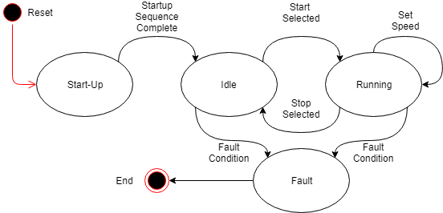

Figure 3 - VSD State Transitions

## 2.3 Faults

Faults fall into one of two categories, EIC and EOC. An EIC fault is an internal logic fault, often caused by improper input to the device or faulty equipment in the Microprocessor section. An EOC fault is an output fault, often caused by the load being faulted, not properly sized, or faulty equipment in the Power Electronics section. The first step in clearing an EIC fault is to cycle power to the device. If the fault occurs again repairs may need to be made to the Microprocessor section or a firmware update may be required. The first step in clearing an EOC fault is to determine if the load is in good working order. If the load is not faulted and the fault occurs again repairs may need to be made to the Power Electronics section. A full list of faults and fault codes can be found below:

|  |  |  |  |
| --- | --- | --- | --- |
| Code: | Name: | Causes: | Solution |
| EIC-00 | Internal Software Fault | -Fault in internal logic | -Cycle power to VSD |
| EIC-01 | Start-up Sequence Fault | -Fault in start-up sequence | -Cycle power to VSD |
| EIC-10 | User Input | -Wrong input on menu pushbuttons | -Cycle power to VSD |
| EIC-11 | Setpoint Out of Bounds | -Setpoint input is out of bounds | -Setpoint dial is not connected to appropriate input |
| EIC-30 | Reserved for Future Use |  |  |
| EIC-40 | Reserved for Future Use |  |  |
| EIC-50 | Reserved for Future Use |  |  |
| EOC-00 | Faulted Drive | -Did not see expected voltage/current output | -Ensure load is connected  -Ensure CT is connected properly and not faulted  -Ensure PT is connected properly and not faulted  -Replace Power Electronics circuitry |
| EOC-01 | ZFC Input Not Detected | -Did not see expected input from Zero Crossing Detector Module | -Ensure ZFC - PT is working properly  -Replace ZFC module |
| EOC-10 | Overcurrent | -Current to load above maximum safe value | -Ensure load is not faulted and properly sized for drive |
| EOC-20 | Reserved for Future Use |  |  |
| EOC-30 | Reserved for Future Use |  |  |
| EOC-40 | Reserved for Future Use |  |  |
| EOC-50 | Reserved for Future Use |  |  |

# 3. Components

The following components make up each section of the VSD:

|  |  |
| --- | --- |
| Microprocessor Section | |
| STM32F100RB | -Microcontroller system, including all support circuitry |
| Regulator | -Power regulation circuit necessary to convert 120VAC to 5VDC and 3.3VDC for microcontroller and user interface |
| User Interface | -Contains pushbuttons, setpoint dial, LCD screen, indicator LED’s, and all support circuitry |
|  |  |
| Power Electronics Section | |
| ZFC Module | -Contains zero-crossing detector circuitry necessary to control firing angle of TRIAC circuit |
| TRIAC Module | -Contains main TRIAC and necessary firing circuitry, including a secondary optically coupled firing TRIAC |
| Instrumentation | -Contains potential and current transformers and necessary circuitry required to relay running conditions to the microprocessor and the test point. |
|  |  |